Machine Learning Project – 2



**Q 1.B** Function visualizations for different k and d values:

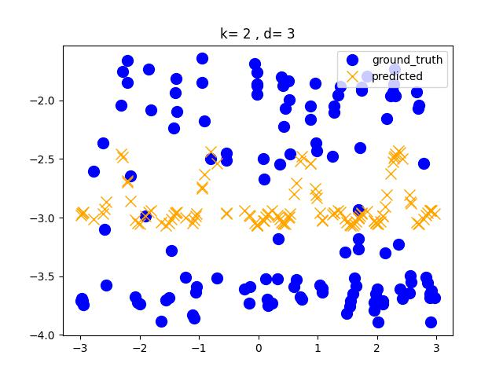

**Q 1.C** Regression Function Evaluations

Minimum test error is obtained for k= 7, d= 4 and minimum test error is 0.006283333433891437

Train vs Test Loss plots for different d-values and k-values to analyze model overfitting.

K = 1: Model is overfitting for d = 2 to d= 6.

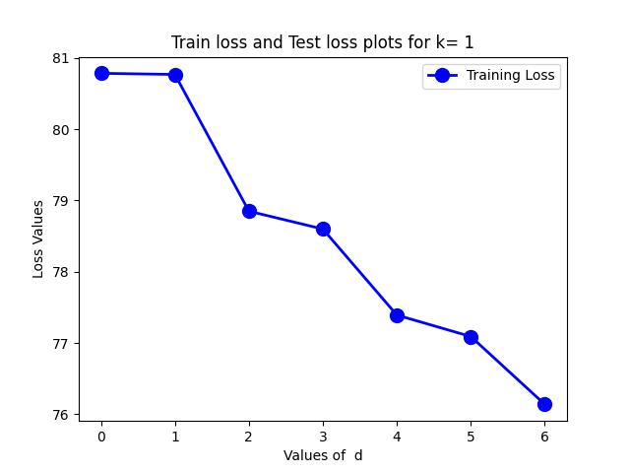

K = 2: Model is overfitting for d = 1 to d= 6.

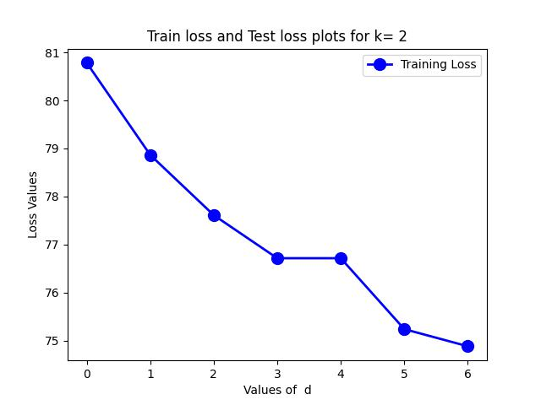

K = 3: Model is overfitting for d = 2 to d= 6.

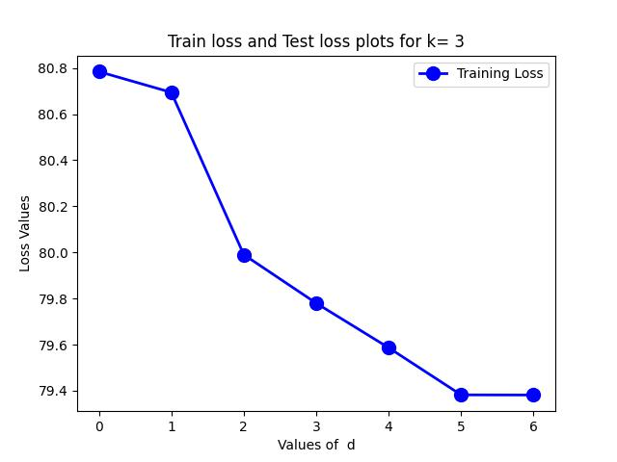

K = 4: Model is overfitting for d = 1 to d = 6.

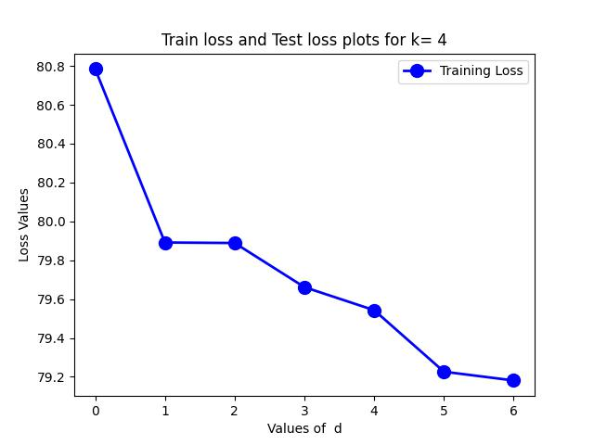

K = 5: Model is overfitting for d = 1, 2, 3, 4, 5

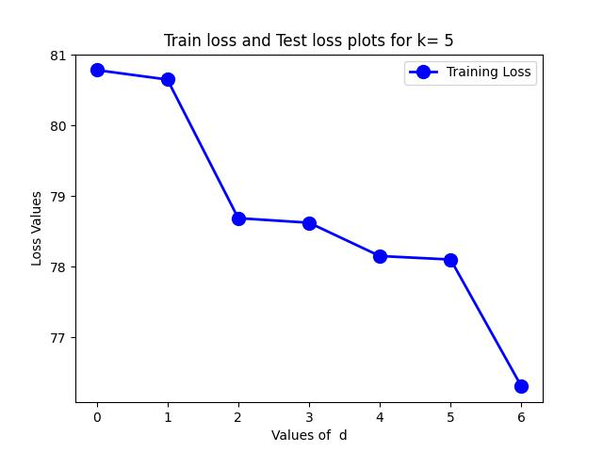

K = 6: Model is overfitting for d = 1, 2, 3, 4.

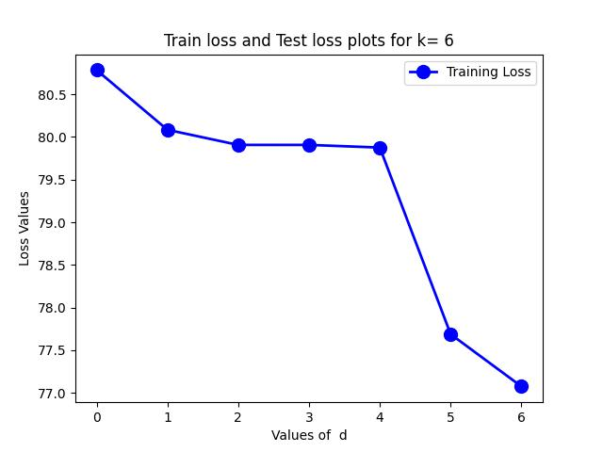

K = 7: Model is fitting properly and there is no overfitting.

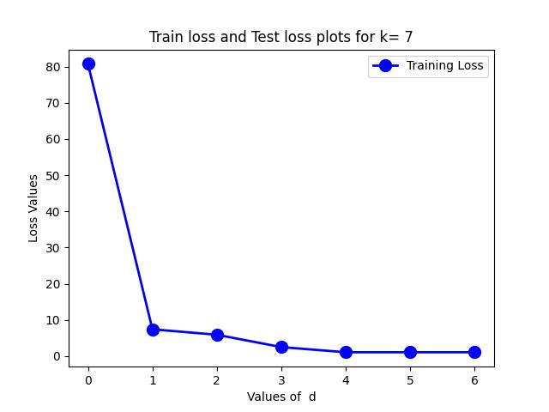

K = 8: Model is overfitting for d=1, 3, 4.

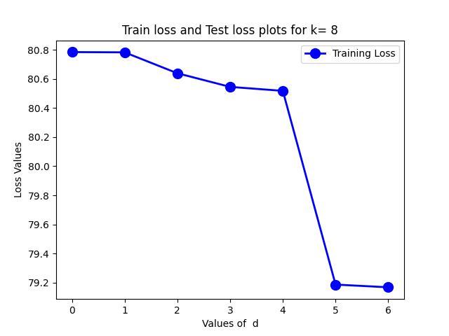

K = 9: Model is overfitting for d=4, 5, 6

K = 10: Model is overfitting for d=1, 2

**Q 1.D** Function visualizations for different k and d values:

Minimum test error is obtained for k= 7, d= 6

Train vs Test Loss plots for different d-values and k-values to analyze model overfitting.

Minimum test error is obtained for k= 7, d= 6 and minimum test error is 0.05194152057155799

K = 1: Model is overfitting for d = 1 to d= 4.

K = 2: Model is overfitting for d = 1 ,2

K = 3: Model is overfitting for d = 4, 5

**Q 2. AB** Function Visualization using Locally weighted Linear Regression

**Q 2. C** Function evaluation on Test set

Squared loss on test dataset with locally weighted linear regression is 5.369357936424441 and is worse than using the best regression model obtained through sin basis functions.

**Q 2. D** Function evaluation on Test set

Squared loss on test dataset using only 20 points is 7.373927468773934 and is worse than using entire training dataset.

**Q 2. E** Based on the test dataset and training dataset losses, I strongly believe that the training and test datasets are generated from the function used in Question 1.

**Q 3. AB**

**

Plot of the learned classification surface projected onto two-dimensional space is shown above.

**Q 3. C** Leave one out validation error

Leave one-out validation error percentage with logistic regression classifier is 30.83333333333333. Based on the leave one out validation error, we can say that logistic regression performed better than KNN and Gaussian NB classifiers.

**Q 3. D** Removing age variable from the training data

Training accuracy of the learned classifier without age variable is 70.83 %

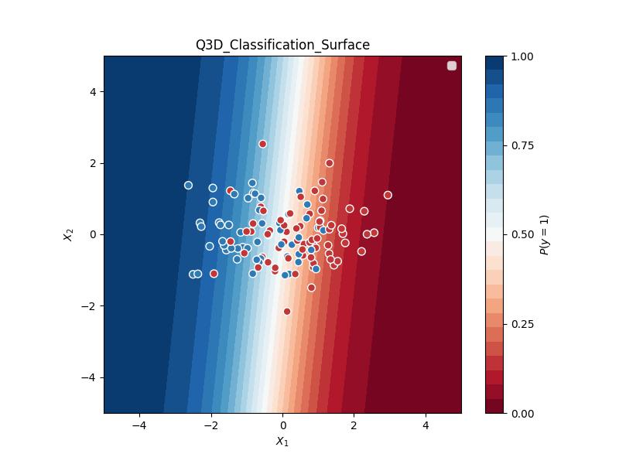

Plot of the learned classification surface without age variable projected onto two-dimensional space is shown above.

Leave one-out validation error percentage without age variable is 29.16666666666667. LOO error reduced after removing age variable suggesting that removing the age variable to be a good choice in terms of model generalization.